Types of Affixes
# Source: AI Source: Provided by: [Data Path: Persons Table -> ID Column: 1, Name_En Column: Motasem Essam] -> From: [Chatgpt (GPT-4-turbo)] on [7/29/2025]
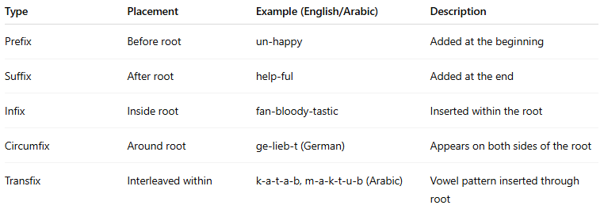

Type | Placement | Example (English/Arabic) | Description
Prefix | Before root | un-happy | Added at the beginning
Suffix | After root | help-ful | Added at the end
Infix | Inside root | fan-bloody-tastic | Inserted within the root
Circumfix | Around root | ge-lieb-t (German) | Appears on both sides of the root
Transfix | Interleaved within | k-a-t-a-b, m-a-k-t-u-b (Arabic) | Vowel pattern inserted through root

